A323-EUR-Vinca-Neolithic-Ceramic-Anthropomorphic Figurine, 5500-4500 BCE

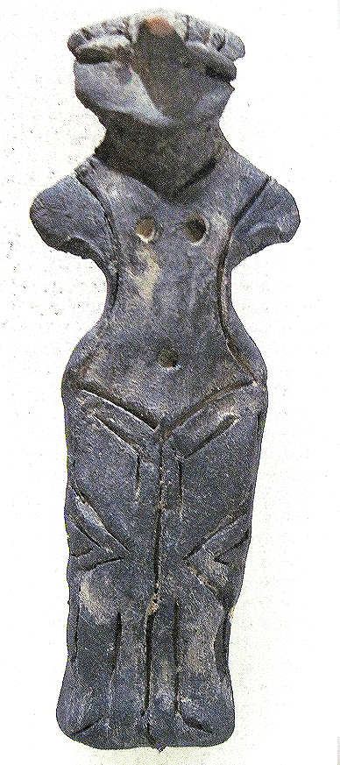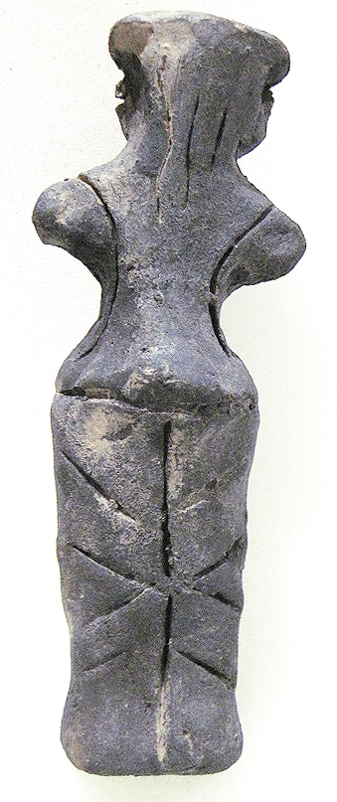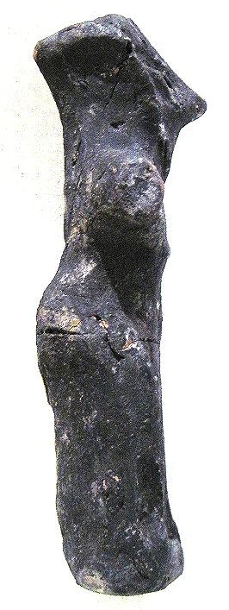

Figs. 1-3. Vinča-Neolithic-Ceramic-Female Anthropomorphic Figurine, 5500-4500 BCE.

**Case no.: 3**

**Accession Number: A323**

**Formal Label:** Vinča-Neolithic-Ceramic-Female Anthropomorphic Figurine, 5500-4500 BCE

**Display Description:**

The Vinča culture was named for its type site, Vinča-Belo Brdo tell or mound, on the right bank of the Danube River in Belgrade, Serbia.

Early phase anthropomorphic figurines from this site have triangular heads, flat bodies with short outstretched arms and closed legs. The treatment of facial and body features was done by simple incisions into the clay without modeling. Later phase anthropomorphic figurines are more polygonal, with more pronounced facial features, such as modeled noses and distinctive half-moon eyes and modeled arms. For both periods no indication of a mouth is present. Some theorize that these figurines are deities for ritual practice, while others see them as ancestral cult objects.

This Vinča ceramic female anthropomorphic figurine is from the later period, and has a pronounced, straight nose, and eyes that are set high on the head, are modeled. Its breasts and navel are marked by punctates and it wears long hair in the back that extends to its shoulders. Its lower body is covered by a flounced kulotte held by suspenders extending to the ground from below the navel. Feet are not indicated.

The midline of the figurine is curved by ca 4o on the right side. This may be an accident of manufacture or it might be displaying a person’s curved spine. If it is the latter this a rare case of documented Neolithic scoliosis.

**LC Classification:** GN776.2.V5

**Date or Time Horizon:** Middle Neolithic/Copper Age-5500-4500 BCE.

**Geographical Area:** SE Europe

**Map, GPS coordinates:** 44°45′43″N 20°37′23″E (Vinča Belo-Brdo, Serbia)

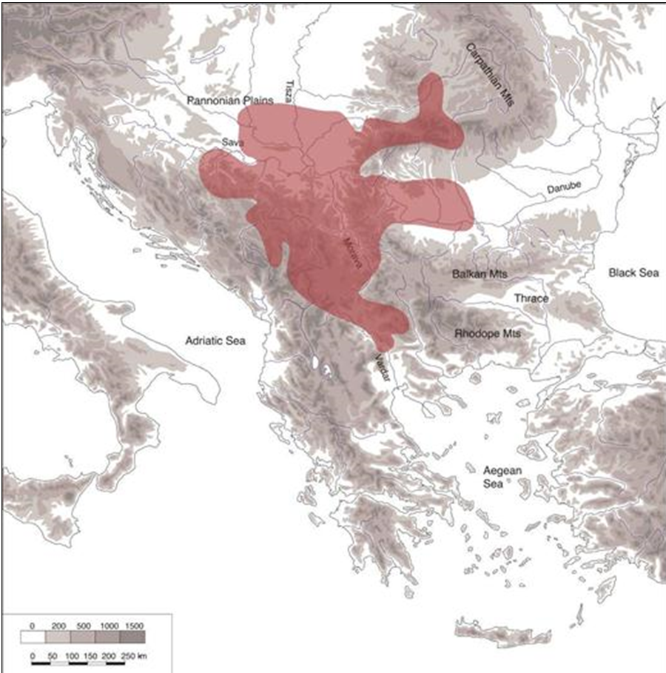

Fig. 4. Map of the extent of Vinča culture. Adapted after Kaiser and Voytek (1983: 333, fig. 1) and Chapman (1981); from https://www.ucl.ac.uk/silva/rise-metallurgy-eurasia/images/5.1.jpg?hires

Fig. 5. Map of the Central Balkans. Beograd = Belgrade, Serbia, and the approximate location of the Vinča Belo-Brdo site. From http://drakenberg.weebly.com/uploads/6/7/4/7/6747442/9582880.jpg?578

**Cultural Affiliation:** Vinča Culture

**Medium:** clay

**Dimensions:** H 122.13 mm, 4.81 in

**Weight: 258 gm, 9 oz**

**Provenance:** Anglo-Antiquities, 33 Medlock Grove, Didcot, Oxfordshire, ox11 7xy, United Kingdom

**Discussion:**

The Vinča culture emerged at the inception of the Middle Neolithic/Copper or Chacolithic Age (5500-4500 BCE) with origins that are debated as either having derived from the earlier Starčevo culture (6200-4500 BCE) of the area, which has been reputed to have been the source of a Proto Indo-European language (PIE), or from migrations from a PIE homeland of a Kurgan or mound-building culture in the Pontic steppe north of the Black Sea (The Kurgan Hypothesis).

Vinča settlers initiated a cultural uniformity that they expressed in farming, making dark pottery fired under reducing conditions comprising zoomorphic and anthropomorphic figurines and making clay tablets with so-called Vinča symbols, which have the appearance of proto-writing (Winn Luca 2008: 26). The type site of the Vinča-Belo Brdo comprised 7 m of Vinča cultural debris overlying 2 m of the previous Starčevo culture. Elsewhere in Serbia and the western part of Romania large Vinča tell villages ranged up to 100 ha in size.

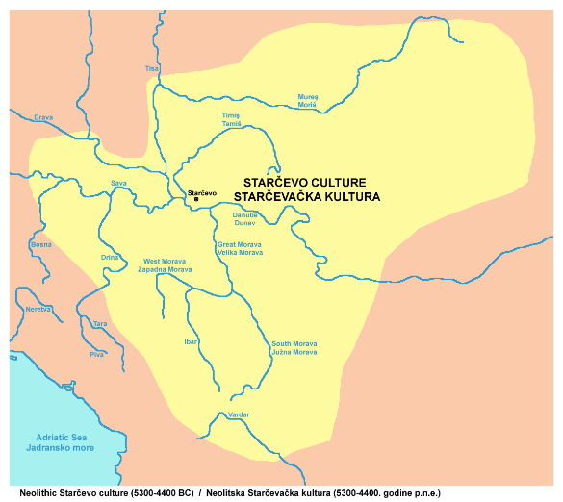

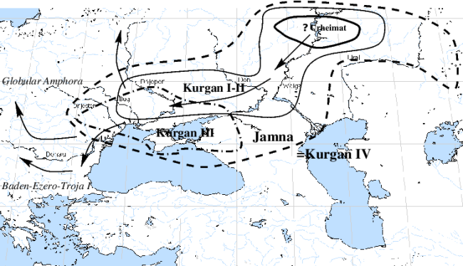

Fig. 6. The extent of the Starčevo culture (6200-4500 BCE) in southeast Europe. After https://upload.wikimedia.org/wikipedia/commons/thumb/e/ea/Starcevo_culture.png/450px-Starcevo_culture.png

Fig. 7. Overview of [Marija Gimbutas](https://commons.wikimedia.org/w/index.php?title=Marija_Gimbutas&action=edit&redlink=1)' [Kurgan](https://commons.wikimedia.org/w/index.php?title=Kurgan&action=edit&redlink=1) hypothesis showing the PIE migrations from the Pontic Steppes into southeastern Europe. Made by [en:User:Dbachmann](https://en.wikipedia.org/wiki/User:Dbachmann) and originally at [en:Image:Kurgan map.png](https://en.wikipedia.org/wiki/Image:Kurgan_map.png).

**References:**

Biagi, P. Gratuze, B. and Boucetta, S. 2007. “New data on the archaeological obsidians from Banat and Transylvania (Romania).” In M. Spataro and P. Biagi (eds.) *A short walk through the Balkans: The first farmers of the Carpathian basin and Adjacent regions*. Quaderno 12. Trieste: Societa per la preistoria e protoistoria della regione Friuli-Venezia Giulia, pp. 129-39.

Chapman, J. 1981. *The Vinča Culture of South East Europe. Studies in chronology, economy and society*. British Archaeological Reports, International Series 117, Oxford: Archeopress. 2v.

Gimbutas, Marija. 1970. “Proto-Indo-European Culture: The Kurgan Culture during the Fifth, Fourth, and Third Millennia B.C.” In Cardona, George; Hoenigswald, Henry M.; Senn, Alfred, Indo-European and Indo-Europeans: Papers Presented at the Third Indo-European Conference at the University of Pennsylvania. Philadelphia: University of Pennsylvania Press, pp. 155–197.

Haak, Wolfgang *et al*. 2015. “Massive migration from the steppe is a source for Indo-European languages in Europe.” bioRxiv preprint first posted online Feb. 10, 2015; doi: http://dx.doi.org/10.1101/013433 Now published in *Nature* doi: [10.1038/nature14317](http://dx.doi.org/10.1038/nature14317)

Holmberg, E.J. 1964. “The Appearance of Neolithic Black Burnished Ware in Mainland Greece,” *American Journal of Archaeology* 68(4): 343-8.

Kaiser, T. and B. Voytek. 1983. “Sedentism and economic change in the Balkan Neolithic,” *Journal of Anthropological Archaeology* 2(4): 323-353.

Luca, S. A. 2008. “The Neolithic and Eneolithic periods in Transylvania.” In Institute of Archaeomythology and Muzeul Brukenthal, *The Danube script: Neo-eneolithic writing in southeastern Europe* [exhibition catalogue]. Sebastopol, California, Institute of Archaeomythology, pp. 23-38.

Özdoğan, M. 2003. “The Prehistory of Northwestern Turkey - The synoptic overview of the latest evidence.” In D.V. Grammenos (ed.) *Recent Research in the Prehistory of the Balkans*. Thessaloniki: Archaeological Institute of Northern Greece and the Archaeological Receipts Fund, pp. 329- 68.

Thissen, L. (2001) “Time trajectories for the Neolithic of Central Anatolia, CANeW project,” http://www.canew.org/files/Thissen%20lecture.pdf, [23.11.2001]: 1-26.

─── (2007) “CANeW Central Anatolia and Cilicia 14C Chart, CANeW project,” http://www.canew.org/cachronobox.html, updated at 16.03.2007.

Vasic, Mīloje M. 1932-1936. *Preistoriska Vinča*. Beograd [Belgrade]: Državne Štamparije. 4 v.

Winn, Milton MacChesney. 1981. [*Pre-writing in Southeastern Europe: the sign system of the Vinča culture ca. 4000 B.C.*](http://www.worldcat.org/title/pre-writing-in-southeastern-europe-the-sgin-system-of-the-vinca-culture-ca-4000-bc/oclc/781534609&referer=brief_results) Calgary, Alberta: Western Publishers.